LAB EXAM OUTPUT
NAME:PINKAPAANIP
ROLLNO: 24UG00530
cs and AI

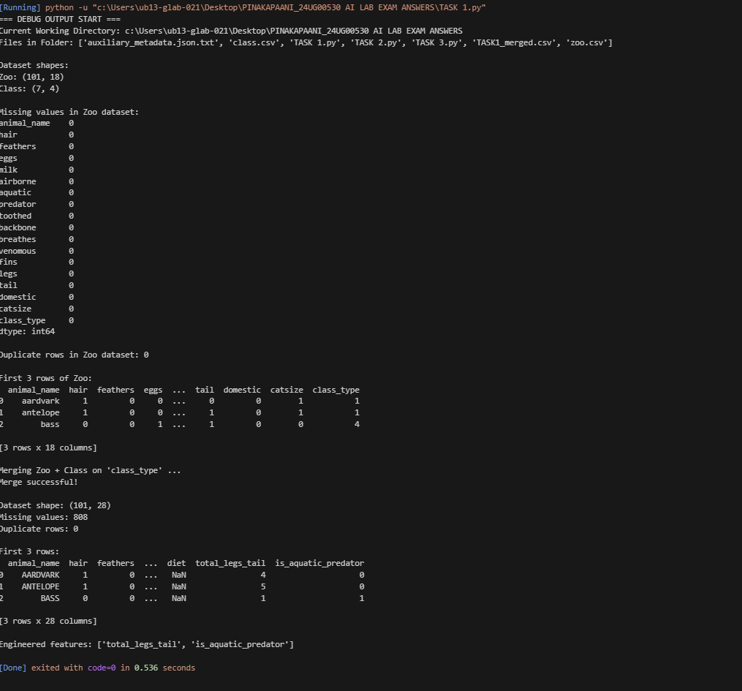
Seat no :52
TASK 1 code OUTPUT:

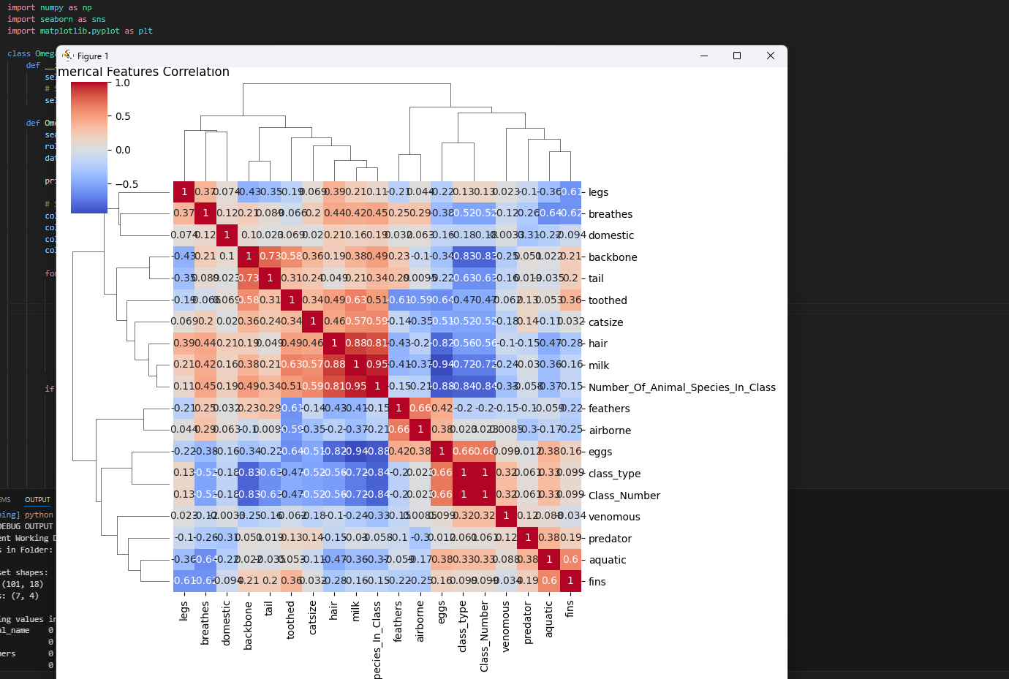
TASK 2 code OUTPUT:
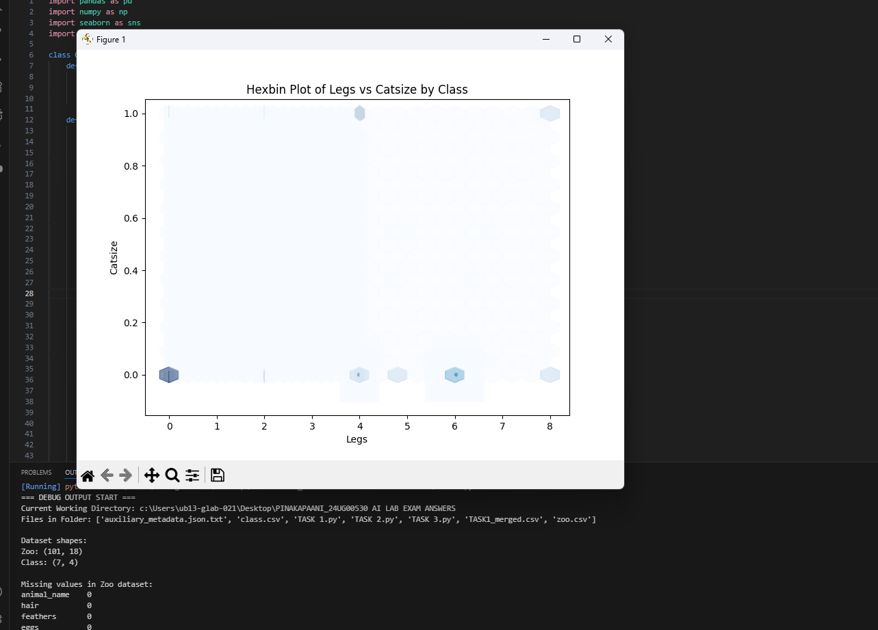
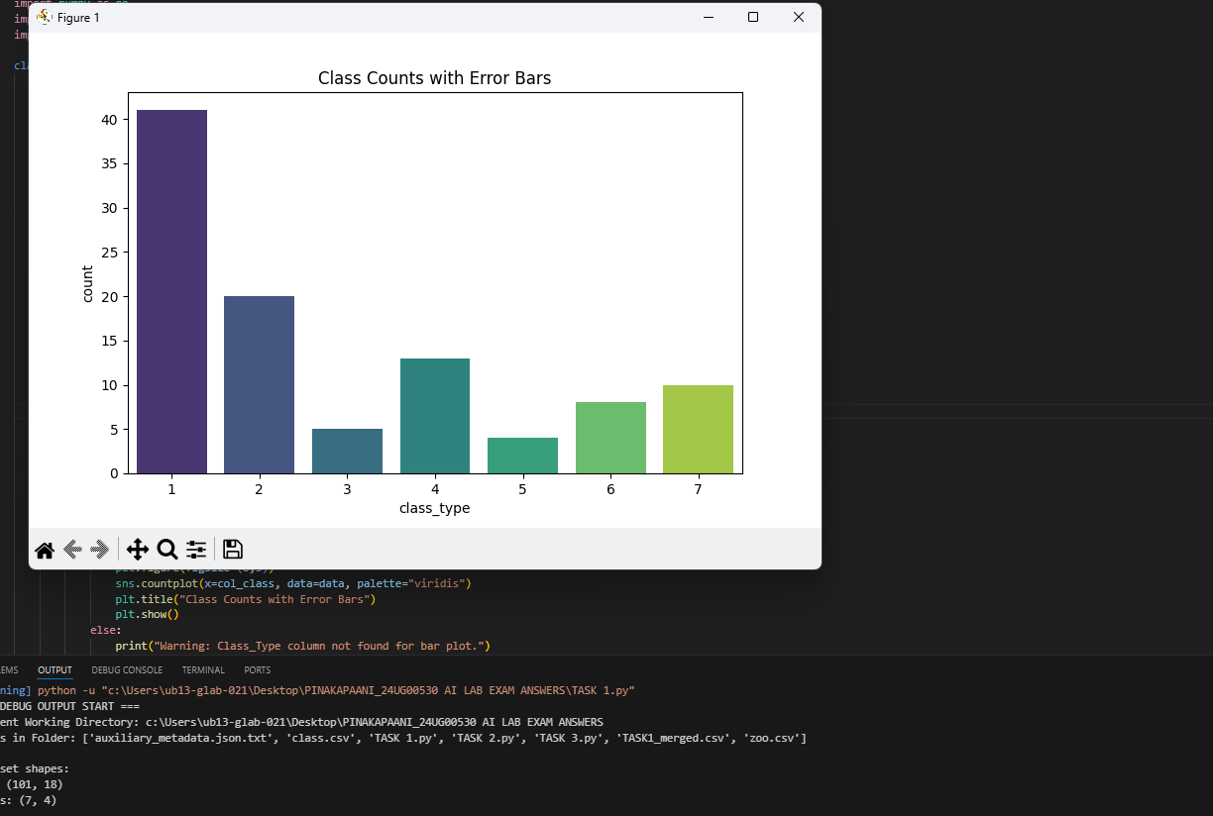

TASK 3 code OUTPUT:
